HS550 Fall, 2014

Midterm Solution

**Problem 1**

$$Mean=\frac{3+6+1+8+15+3+6+9}{8}=6.375$$

$$Order the observations from small to large:1, 3, 3, 6, 6, 8, 9 ,15.$$

$$Median=\frac{6+6}{2}=6$$

$$Variance=({\left(3-6.375\right)}^{2}+{\left(6-6.375\right)}^{2}+{\left(1-6.375\right)}^{2}+{\left(8-6.375\right)}^{2}+{\left(15-6.375\right)}^{2}+{\left(3-6.375\right)}^{2}+{\left(6-6.375\right)}^{2}+(9-6.375)^2)/8=16.98438$$

$$Standard Deviation=\sqrt{16.98438}=4.12121$$

$$25th quartile=\frac{3+3}{2}=3$$

$$75th quartile=\frac{\left(8+9\right)}{2}=8.5$$

$$Inter-quartile range IQR=Q_{3}-Q_{1}=8.5-3=5.5$$

**Problem 2**

$$OR=\frac{3*61}{16*20}=0.571875≈0.572$$

Interpretation: Among the 100 Umich athletes participated in the study, the odds of having Head Trauma (HT) for female is 0.572 times the odds of having HT for male.

Or: Among the 100 Umich athletes participated in the study, the odds of having Head Trauma (HT) for male is 1.748 times the odds of having HT for female.

$$CI for\ln\left(OR\right):\ln\left(OR\right)±Z_{\frac{α}{2}}SE\left(\ln\left(OR\right)\right)=\ln\left(0.572\right)±1.96*\sqrt{\frac{1}{3}+\frac{1}{20}+\frac{1}{16}+\frac{1}{61}}=\left(-1.89139, 0.773715\right)$$

$$CI for OR:\exp\left(-1.89139, 0.773715\right)=\left(0.150863, 2.167806\right)$$

Interpretation: If repeated the study for enough times, we have 95% confidence that this CI $\left(0.150863, 2.167806\right)$ would cover the true Odds ratio. The odds ratio can be as low as 0.150863 or as high as 2.167806.

**Problem 3**

a. The probability that the athlete has experienced HT given it’s a female is

$$P=P\left(HT | F\right)=\frac{3}{23}≈13.04\%$$

b. The probability that the athlete is a male and has not experienced HT is

$$P=P\left(NHT,M\right)=\frac{61}{100}=61\%$$

**Problem 4**

Let X denote the serum cholesterol level of 15-year-olds, $X∼N\left({170,25}^{2}\right)$

Let Z denote the standard normal distribution, $Z∼N\left(0,1\right), Φ=cdf of Z$

1. 166 or less

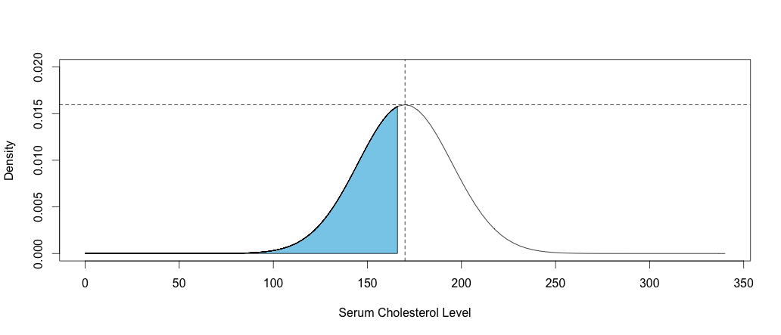

$$P\left(X≤166\right)=P\left(\frac{X-170}{25}≤\frac{166-170}{25}\right)=P\left(Z≤-0.16\right)=Φ\left(-0.16\right)≈0.4364$$

1. Between 123 and 170

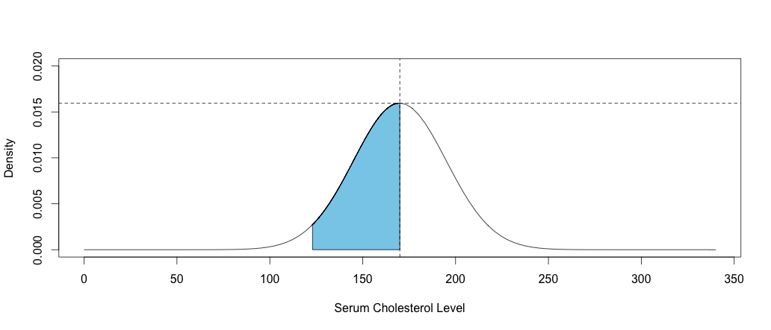

$$P\left(123≤X≤170\right)=P\left(\frac{123-170}{25}≤\frac{X-170}{25}≤\frac{170-170}{25}\right)=P\left(-1.88≤Z≤0\right)=Φ\left(0\right)-Φ\left(-1.88\right)=0.5-0.03005404≈0.4699$$

**Problem 5**

Three core components good design of experiments (DOE):

1. Randomization: in order for the sample to be representative enough of the population, it is critical to sample randomly. Randomization is the process of assigning individuals randomly into treatment and control group and this ensure that any difference between the treatment and control group is due to chance alone.
2. Comparison: It is not always possible to have independent measurements and control groups are often used for comparisons. It is important to make sure that the treatment group and control are statistically similar so that the difference is caused by the treatment we are studying on instead of any existing difference between the two groups.
3. Replication: replicate experiments to further estimate the true effect of a certain treatment. We can not easily run into a conclusion about the treatment with a single test and replication is important for a comprehensive study.